Rocks vs Minerals - 7 Key Differences
Do you know the difference between a diamond and a rock? Diamonds are minerals and you are not supposed to call them rocks. Do you know how to tell a mineral from a rock? It may not seem important to many people, but being able to identify rocks and minerals is big business in the mining exploration industry.
Make some notes from this page:
Put a heading (a) Minerals versus Rocks in your notebook, and copy the highlighted text. Then answer the Qs
Let’s take a closer look at the main differences between rocks and minerals so that you won’t make the common mistake of calling a diamond a “rock”.

Rocks
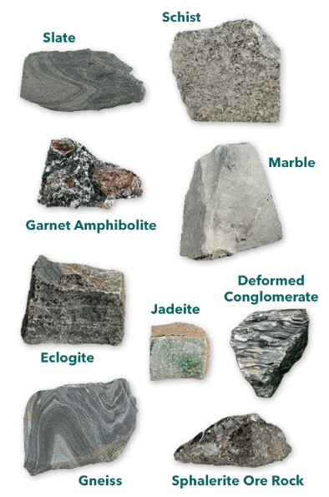
Rocks are solid and naturally occurring substances. Rocks are categorised into three main groups by the way they are formed – namely sedimentary, metamorphic and igneous. Soil is composed of rock particles and organic matter. Rocks are not homogenous and don’t have a specific chemical composition (rocks are a mixture). Rocks can be a mixture of different minerals or non-mineral substances and can also contain organic traces. Rocks are generally classified by their appearance using colour, layering, hardness, and size of the particles within the rock.

Minerals
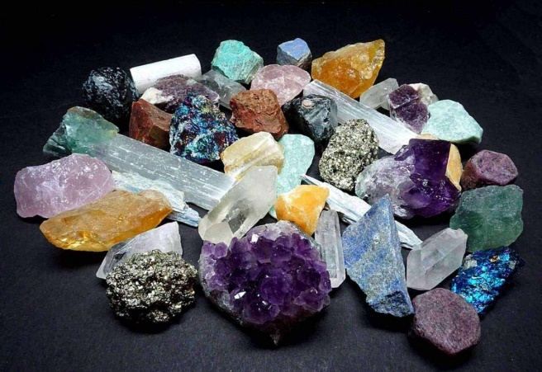
Minerals are solid, crystalline substances that occur naturally. They are made of very specific chemicals. Minerals are homogenous in nature and have a very specific structure). There are over 5 thousand types of minerals. Minerals are identified colour (not always reliable), streak, lustre, breakage, hardness, magnetism, and density.

The Differences between Rocks and Minerals
So, now that you know the major differences between rocks and minerals, let’s have a look at all the details that tell them apart. Check out the mineral vs rock comparison table below to get a clear image of the two substances.
Difference | Minerals | Rocks
1 | - Minerals are homogenous substances with a very specific chemical composition. | - Rocks are aggregates with variable composition and are usually a mix of multiple minerals.
2 | - Minerals are inorganic. | - Rocks can contain organic matter – even fossils!
3 | - Minerals usually have a specific shape. | - Rocks do not have a definite shape.
4 | - Minerals help in blood coagulation, in bone formation and muscle contraction, and some have nutritional value for the human body. | - Rocks don’t have any nutritional value.
5 | - It has a regular, repeating atomic arrangement. | - Rocks do not.
6 | - Minerals are classified according to their chemical and physical properties, but never by the way they were formed. | - Rocks are classified into 3 groups depending on how they are formed.
7 | - The science that studies minerals is called mineralogy. | - Petrology is the science that studies rocks.
Questions (Answer in your notebook)
1. If you had to list three differences between minerals and rocks, which three do you think are the most important? Copy these into your notebook.
2. Which of the seven differences in the table above are mentioned in the article? List them in your notebook.
3. What is it about a diamond that makes it a mineral and not a rock? Answer this question in your notebook.

